3D Shape Hunt
Walk around your home and look for objects that are 3D shapes. Record your findings in the table below. You can tick, draw pictures or write names of the objects you find.

Shapes to find: cube, cuboid, cone, cylinder, sphere.

Cube   | Cuboid  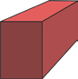 | Cone   | Cylinder   | Sphere   | Object

